# Informações do estudo

Referência: Lin

Grandeza: Força

Tipo: Força resultante

Material: S55C high carbon steel

Ferramenta: TNMG160404L2G

Número de experimentos: 27

Observações:  
Tool holder: MTJNL2525M16  
Diameter: 64.5 mm  
Length: 250 mm

# Unidades

Velocidade: m/min

Avanço: mm/rev

Profundidade de corte: mm

Força: N

# Dados de teste

|  |  |  |  |
| --- | --- | --- | --- |
| Força | n | f | a |
| 192.4 | 202.63 | 0.08 | 0.35 |
| 1019.8 | 202.63 | 0.32 | 1.25 |
| 490.0 | 121.58 | 0.08 | 1.25 |
| 598.9 | 121.58 | 0.2 | 0.8 |
| 314.1 | 121.58 | 0.2 | 0.35 |
| 432.7 | 86.12 | 0.32 | 0.35 |

# Dados de treino

|  |  |  |  |
| --- | --- | --- | --- |
| Força | n | f | a |
| 827.1 | 121.58 | 0.32 | 0.8 |
| 481.7 | 86.12 | 0.08 | 1.25 |
| 762.2 | 202.63 | 0.32 | 0.8 |
| 782.5 | 86.12 | 0.2 | 1.25 |
| 588.4 | 86.12 | 0.2 | 0.8 |
| 188.2 | 121.58 | 0.08 | 0.35 |
| 424.7 | 121.58 | 0.32 | 0.35 |
| 1111.7 | 121.58 | 0.32 | 1.25 |
| 1076.1 | 86.12 | 0.32 | 1.25 |
| 352.2 | 121.58 | 0.08 | 0.8 |
| 316.8 | 202.63 | 0.08 | 0.8 |
| 298.8 | 86.12 | 0.2 | 0.35 |
| 737.9 | 202.63 | 0.2 | 1.25 |
| 396.2 | 202.63 | 0.32 | 0.35 |
| 339.5 | 86.12 | 0.08 | 0.8 |
| 825.6 | 121.58 | 0.2 | 1.25 |
| 283.8 | 202.63 | 0.2 | 0.35 |
| 185.9 | 86.12 | 0.08 | 0.35 |
| 801.1 | 86.12 | 0.32 | 0.8 |
| 529.7 | 202.63 | 0.2 | 0.8 |
| 452.2 | 202.63 | 0.08 | 1.25 |

# RN

Número de neurônios: 58

Taxa de aprendizado: 1.000000e-02

Número de épocas: 382

2° camada: True

Função de ativação: tanh

# Erros

**Dados de teste**

* Erro relativo médio: 2.94
* Coeficiente de correlação: 1.0
* Coeficiente de determinação: 1.0
* MSE: 197.05
* RMSE: 14.04

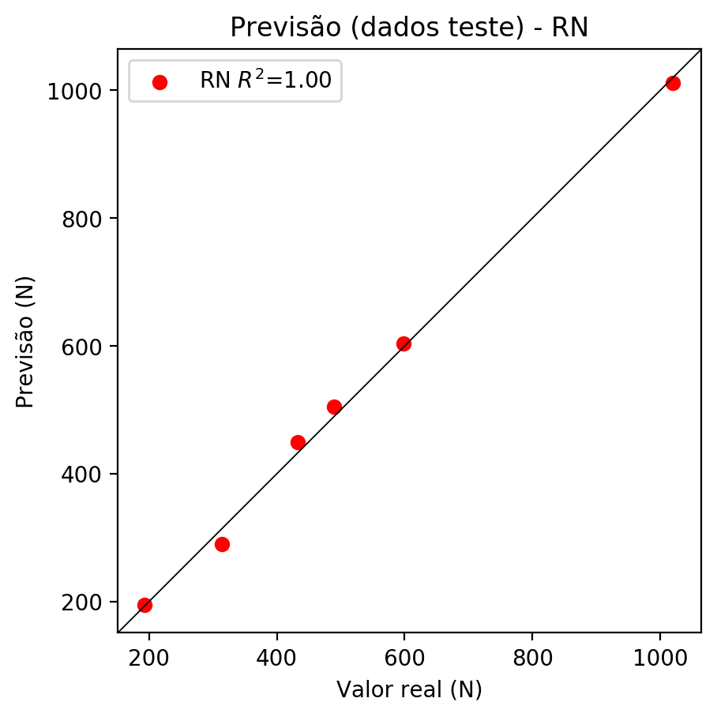

**Dados de treino**

* Erro relativo médio: 0.31
* Coeficiente de correlação: 1.0
* Coeficiente de determinação: 1.0
* MSE: 2.44
* RMSE: 1.56

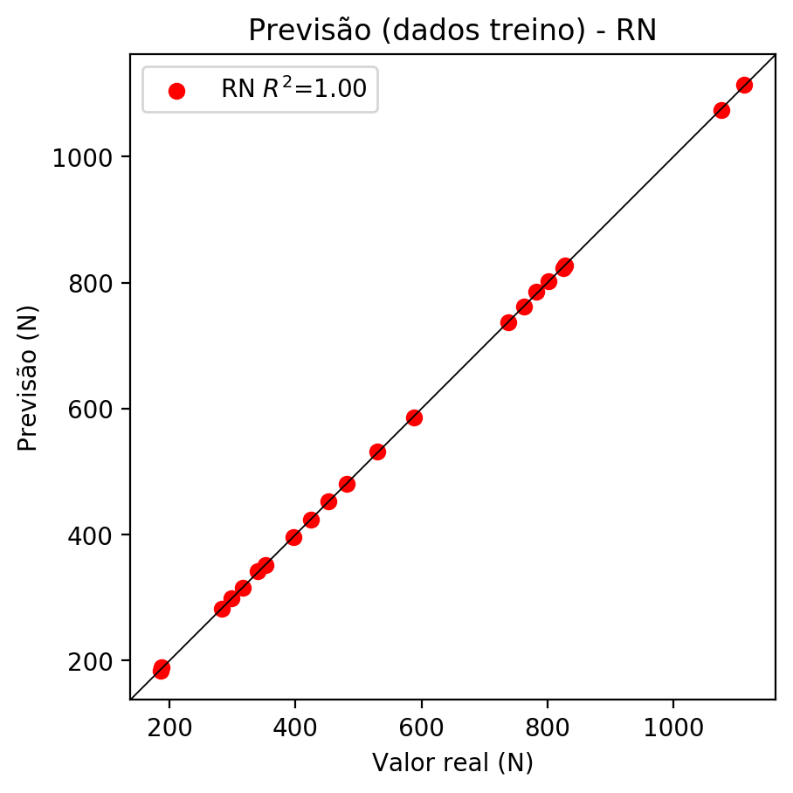

# Pesos

Pesos - camada oculta 1

[[ 0.19728097 0.04534544 -0.2019768 -0.03408534 0.15350263 -0.20023423  
 -0.02202223 -0.04646917 -0.08019755 0.11618045 -0.35453948 0.20933577  
 0.11183423 -0.03139548 -0.08347238 -0.23795393 0.11386302 -0.10876087  
 -0.27837172 0.44210923 0.19044712 0.18899809 0.00346554 0.02353132  
 -0.05772868 -0.30677035 0.3040067 0.17961879 0.16856633 -0.20547053  
 -0.12970874 -0.31754246 -0.0977267 -0.38911527 -0.04341224 -0.19444853  
 0.10430915 0.14559738 -0.2581412 -0.1289524 0.18931557 0.10748787  
 0.3014504 0.211338 0.1630304 -0.01531636 -0.01926694 -0.21067902  
 0.25017136 0.34704894 0.22913985 0.27147654 0.01700877 -0.12815447  
 -0.11386443 0.155448 -0.0337418 0.08482707]  
 [-0.26347446 -0.20856245 0.14832082 -0.19748312 -0.24903288 0.12610035  
 0.27302846 -0.22021502 -0.09519656 0.08419453 -0.25562468 -0.18154387  
 -0.06713888 0.03643303 -0.04801199 -0.15524173 0.10017078 -0.16875523  
 0.11818149 0.14812353 0.14056857 0.01614037 0.14764288 -0.2241759  
 -0.2893383 -0.00357188 -0.1257787 0.16739184 0.04714633 -0.28741798  
 -0.21545124 0.22897018 -0.16934694 -0.15605338 -0.25932753 0.06268235  
 -0.08779643 -0.21148302 -0.27362746 0.12617312 0.07931842 -0.21143723  
 0.14853598 -0.05251218 0.22199844 -0.15289615 -0.26063883 -0.24501283  
 -0.02233984 -0.16035624 0.04193332 0.14906146 0.06586302 -0.13765016  
 0.24802369 0.17948581 0.12074653 0.25056264]  
 [ 0.06427482 -0.15942934 -0.23934077 -0.10976766 0.06572519 -0.29656607  
 0.00732014 -0.07796979 0.31431746 -0.03978087 0.3492228 -0.08397774  
 -0.2793742 -0.1204278 0.14451915 0.09353716 0.02352752 0.13455434  
 0.29771233 0.08221129 -0.03696317 0.12718792 -0.3214375 0.33758235  
 -0.1672476 -0.29152083 0.06831604 -0.19314817 0.07088318 -0.12062332  
 0.4070034 0.16073327 0.21790116 0.11350959 0.3346584 -0.3438697  
 0.04421455 -0.23973648 -0.17092933 -0.35446775 0.21138518 0.24895146  
 0.17393668 0.00765888 -0.23051304 0.3060766 -0.24124303 -0.03630634  
 -0.09814665 -0.29296726 0.2851925 -0.12765123 -0.21626033 -0.03186953  
 -0.11167343 0.21279098 -0.26141247 0.15134327]]

Bias - camada oculta

[ 0.02093039 0.12900725 0.06022142 -0.05415008 -0.05431452 -0.2841085  
 -0.00121709 0.11256689 0.1711896 -0.49476606 0.30158094 0.05024279  
 0.02185445 0.03233714 -0.08558182 -0.17883305 -0.48709345 0.0343517  
 -0.02498909 0.10033249 -0.287102 -0.3122632 -0.06363692 -0.09791686  
 0.1355513 -0.01786801 -0.04197384 -0.24438655 -0.05649162 0.09334596  
 -0.22929823 0.03169187 0.24706955 -0.06052518 -0.22460711 -0.08050632  
 0.13240694 0.10304899 0.09788664 -0.24079394 0.00106118 -0.1581458  
 -0.01255959 -0.05848774 -0.06558449 0.06931462 0.06277715 0.04678163  
 0.17066306 0.03468693 -0.42795724 -0.12009327 -0.02397696 0.12248751  
 0.08225388 -0.1888252 -0.14391318 0.08262745]

Pesos - camada oculta 2

[[ 0.1172675 0.01181072 -0.115628 ... 0.03476068 0.02696754  
 0.02487683]  
 [-0.23443103 -0.21113932 0.21658319 ... 0.1861459 0.05313859  
 0.23233198]  
 [ 0.03285774 -0.04543469 -0.08525408 ... 0.14299653 -0.21522512  
 0.13888995]  
 ...  
 [-0.11019445 -0.07487957 -0.1751527 ... -0.13344055 -0.14370169  
 0.1927573 ]  
 [ 0.19624342 0.21706006 0.11495788 ... -0.05404977 0.12601748  
 0.100136 ]  
 [ 0.15887633 0.14493331 0.0071289 ... 0.1116682 0.05102111  
 -0.10769432]]

Bias - camada oculta 2

[-0.07783335 0.25604376 0.00644787 -0.0045168 -0.11674236 -0.03140413  
 -0.00056159 0.00195837 -0.01818398 -0.0292181 0.05596665 -0.08931387  
 -0.00389819 -0.02089504 0.0477799 0.01780166 0.00757078 -0.07547582  
 -0.1631328 -0.00632543 -0.0037856 0.03595642 0.08137803 -0.01139252  
 0.07748897 0.01371571 -0.12560561 0.00046375 -0.02844845 -0.00348123  
 0.00773762 0.05637378 -0.01133539 -0.04401142 0.03759278 -0.1192726  
 0.0165943 0.00676558 -0.04851019 0.02247652 -0.12606952 0.03834756  
 0.09360681 -0.01964732 -0.03481021 -0.02563031 0.05377503 -0.02635143  
 0.02249049 0.07927547 0.11422938 -0.04447896 0.00634547 -0.01278375  
 0.13300176 0.07694236 -0.05725996 -0.00068106]

Pesos - camada saída

[[ 2.03731209e-01 9.38712284e-02 -2.13563859e-01 1.84862918e-04  
 1.84282422e-01 -3.72870080e-02 -1.54971154e-02 -1.94064039e-03  
 1.07226660e-02 8.31632540e-02 -2.43282720e-01 1.80510581e-01  
 1.73149351e-02 -2.24820524e-02 -9.22887847e-02 -4.80051041e-02  
 1.80346705e-02 -2.38316189e-02 -2.36211285e-01 1.29345611e-01  
 2.23963574e-01 2.19258025e-01 -6.71615675e-02 5.88790663e-02  
 3.49038057e-02 -2.16021329e-01 3.13361377e-01 4.93019819e-02  
 2.26937145e-01 -1.06510997e-01 4.03979933e-03 -3.00252676e-01  
 -1.44694373e-01 -1.48722485e-01 7.26109045e-03 -1.35981858e-01  
 -1.24751683e-02 5.98538015e-03 -1.74433529e-01 3.22903842e-02  
 1.54292062e-01 9.49326158e-02 1.78041115e-01 2.32972533e-01  
 7.39872679e-02 1.64821874e-02 5.09965047e-03 -1.21853620e-01  
 1.40717834e-01 2.55433291e-01 1.94466725e-01 1.17941931e-01  
 -7.70734670e-03 -1.31097883e-02 -1.20199405e-01 4.12335806e-02  
 -2.07227445e-03 9.23123118e-03]]

# Iterações

|  |  |  |  |  |  |  |
| --- | --- | --- | --- | --- | --- | --- |
| Média | Desvio | n | ln | 2° camada | Função | Épocas |
| -0.0501 | 0.0628 | 10 | 0.1 | False | relu | 38 |
| -0.0601 | 0.0351 | 17 | 0.1 | True | relu | 716 |
| -0.1183 | 0.1113 | 7 | 0.01 | True | tanh | 130 |
| -0.1466 | 0.0782 | 19 | 0.001 | False | tanh | 282 |
| -0.0385 | 0.0272 | 29 | 0.001 | False | relu | 469 |
| -0.1341 | 0.177 | 88 | 0.1 | False | tanh | 926 |
| -0.0437 | 0.0419 | 95 | 0.0001 | True | relu | 984 |
| -0.0442 | 0.0521 | 10 | 0.01 | True | tanh | 865 |
| -0.6218 | 0.4494 | 58 | 0.001 | True | relu | 8 |
| -0.0365 | 0.0335 | 9 | 0.01 | False | tanh | 514 |
| -0.0565 | 0.0433 | 73 | 0.0001 | True | relu | 729 |
| -0.0759 | 0.0657 | 22 | 0.001 | True | relu | 543 |
| -0.0233 | 0.0113 | 25 | 0.1 | True | relu | 562 |
| -0.0337 | 0.0225 | 53 | 0.001 | False | relu | 498 |
| -0.0246 | 0.0143 | 83 | 0.01 | True | relu | 337 |
| -0.1079 | 0.067 | 99 | 0.01 | False | tanh | 16 |
| -0.0384 | 0.0271 | 23 | 0.01 | False | relu | 472 |
| -0.0599 | 0.0581 | 24 | 0.001 | True | relu | 778 |
| -0.0152 | 0.0123 | 58 | 0.01 | True | tanh | 382 |
| -0.1306 | 0.1491 | 35 | 0.1 | False | tanh | 596 |

# RL

# Coeficientes

[ 0. -0.11992696 0.67284015 0.72526795]

# Erros

**Dados de teste**

* Erro relativo médio: 23.16
* Coeficiente de correlação: 0.94
* Coeficiente de determinação: 0.88
* MSE: 8577.36
* RMSE: 92.61

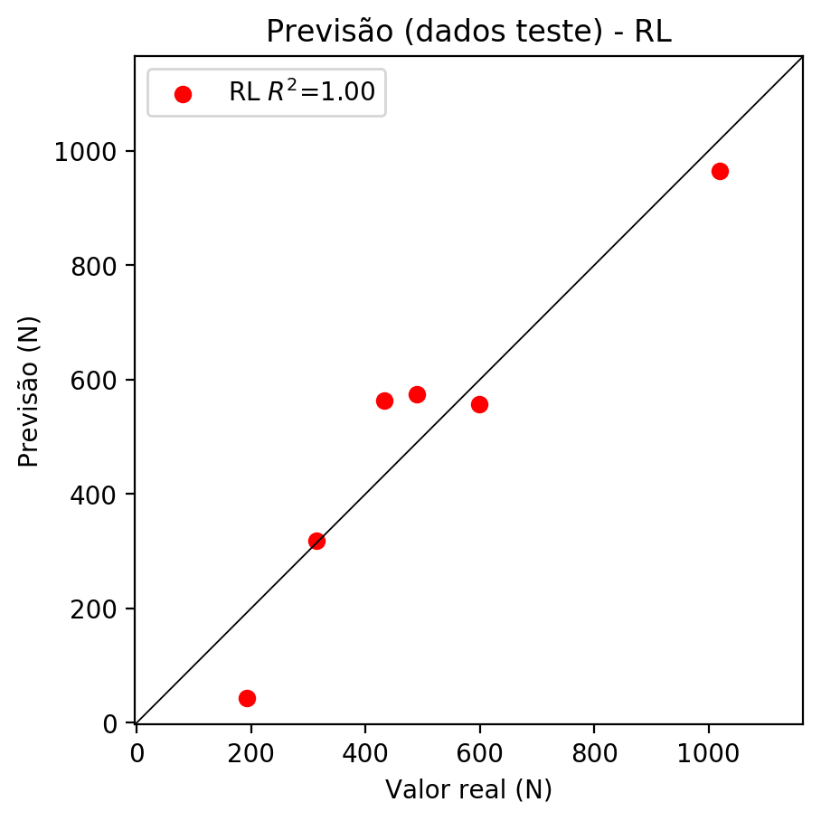

**Dados de treino**

* Erro relativo médio: 12.07
* Coeficiente de correlação: 0.98
* Coeficiente de determinação: 0.95
* MSE: 3483.62
* RMSE: 59.02

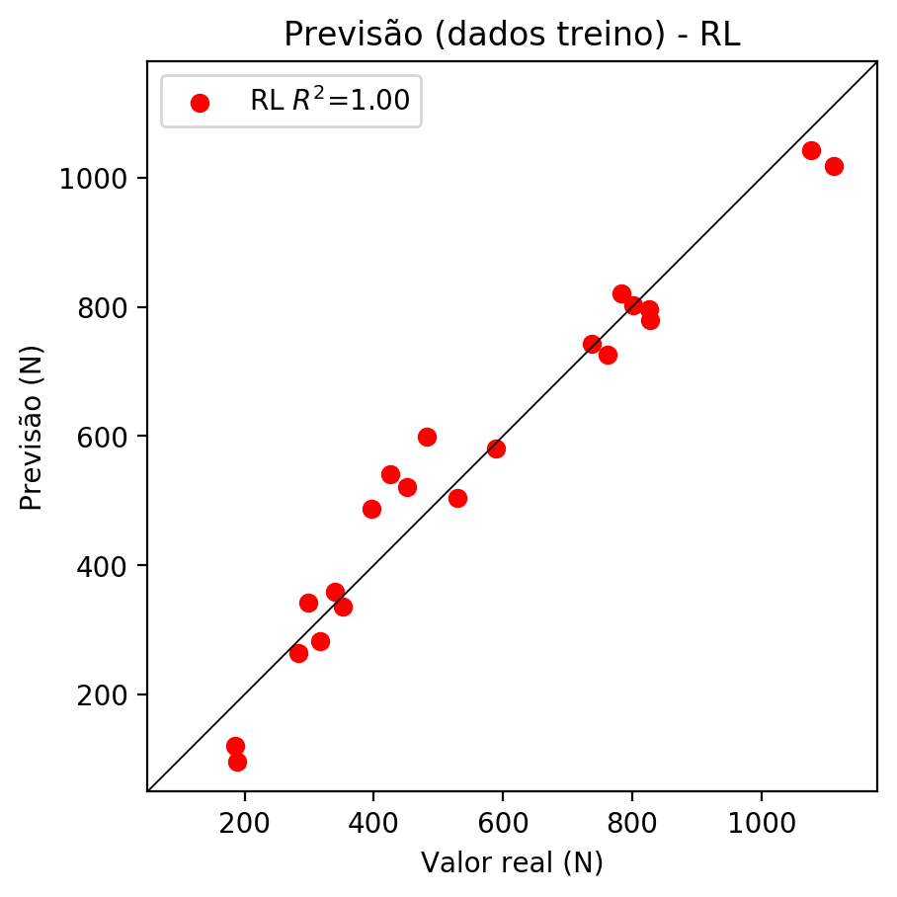

# RP2

# Coeficientes

[ 0.00000000e+00 -2.61018232e-02 6.62963106e-01 7.33152228e-01  
 -8.75180947e-02 6.70687346e-04 -3.67177632e-03 -1.35969405e-02  
 2.27893273e-01 -7.57684496e-02]

# Erros

**Dados de teste**

* Erro relativo médio: 6.12
* Coeficiente de correlação: 1.0
* Coeficiente de determinação: 0.99
* MSE: 729.49
* RMSE: 27.01

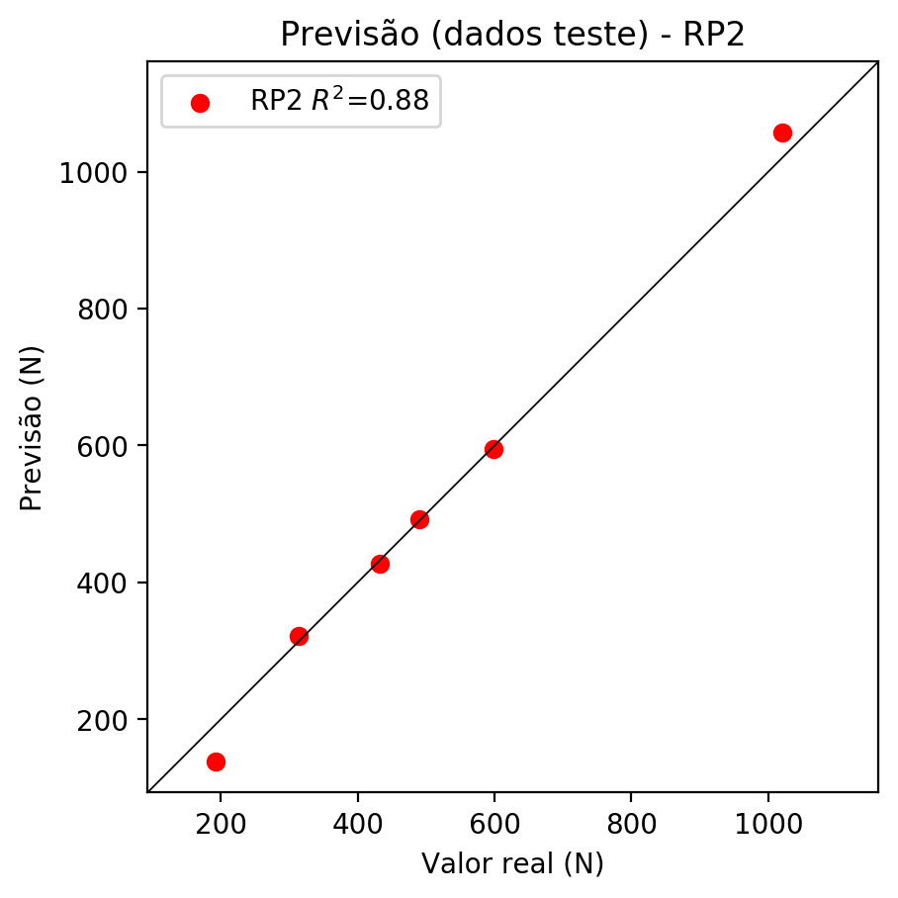

**Dados de treino**

* Erro relativo médio: 2.34
* Coeficiente de correlação: 1.0
* Coeficiente de determinação: 1.0
* MSE: 159.09
* RMSE: 12.61

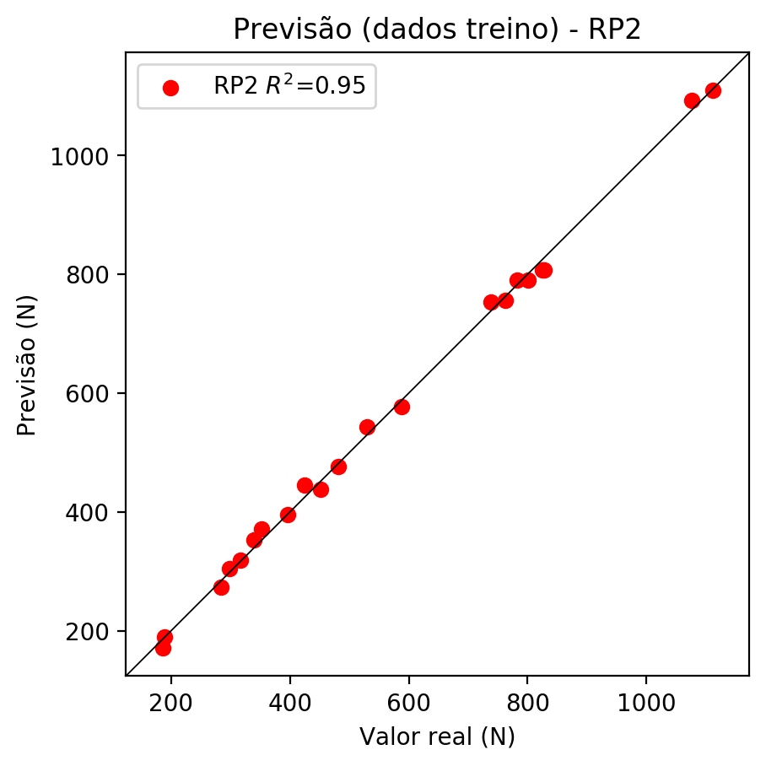

# RP3

# Coeficientes

[ 0. -0.01632915 0.23323936 0.25353431 -0.09137018 -0.0040698  
 -0.00737579 -0.00671627 0.23292783 -0.07554655 -0.02358655 -0.02221945  
 -0.04797204 0.01724874 -0.00066388 0.01677208 0.33690129 -0.00801653  
 -0.05783814 0.36621623]

# Erros

**Dados de teste**

* Erro relativo médio: 2.48
* Coeficiente de correlação: 1.0
* Coeficiente de determinação: 1.0
* MSE: 206.85
* RMSE: 14.38

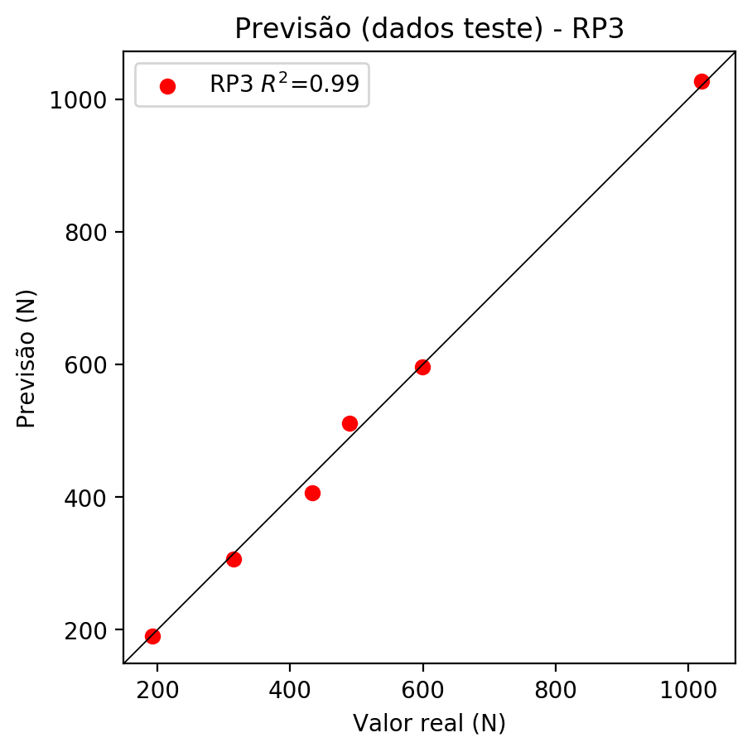

**Dados de treino**

* Erro relativo médio: 0.42
* Coeficiente de correlação: 1.0
* Coeficiente de determinação: 1.0
* MSE: 8.1
* RMSE: 2.85

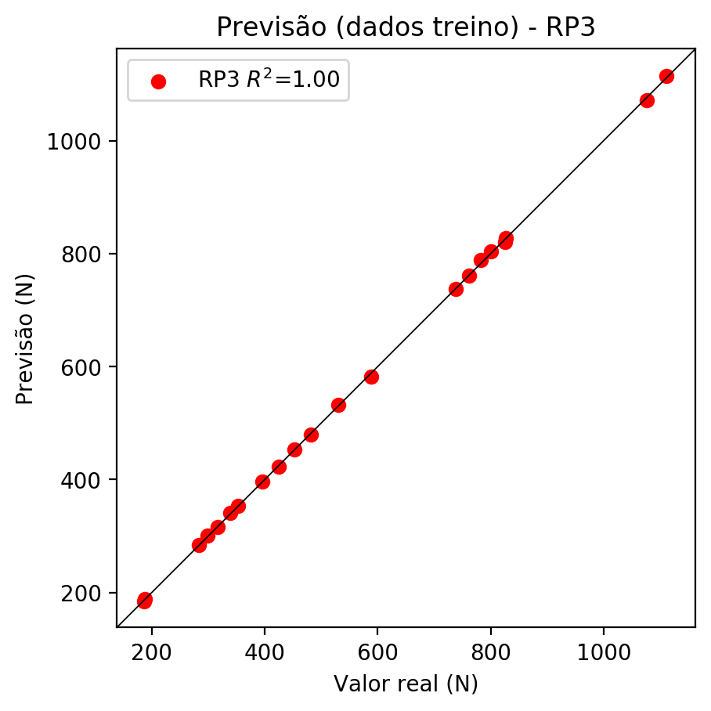

# RP4

# Coeficientes

[-5.55111512e-17 -3.91583567e-03 2.26368449e-01 2.07701530e-01  
 -5.04887816e-02 -2.67353232e-02 -3.00853426e-02 -2.55506593e-02  
 3.96147481e-02 -7.98052291e-03 -5.65620708e-03 -2.37513335e-02  
 4.10013445e-02 1.55849298e-02 -5.16637761e-02 4.56254330e-02  
 3.26976649e-01 7.47217015e-02 -4.18650774e-02 3.00013321e-01  
 -7.45459898e-02 5.49019401e-02 4.23511564e-02 4.72246597e-02  
 4.39984417e-02 -4.74876040e-02 -3.86176891e-02 1.92331554e-02  
 6.97400275e-02 -4.34566060e-02 -3.69065079e-02 5.72213028e-02  
 -2.05282809e-02 5.72213028e-02 -1.15274220e-02]

# Erros

**Dados de teste**

* Erro relativo médio: 22.33
* Coeficiente de correlação: 0.98
* Coeficiente de determinação: 0.89
* MSE: 7883.92
* RMSE: 88.79

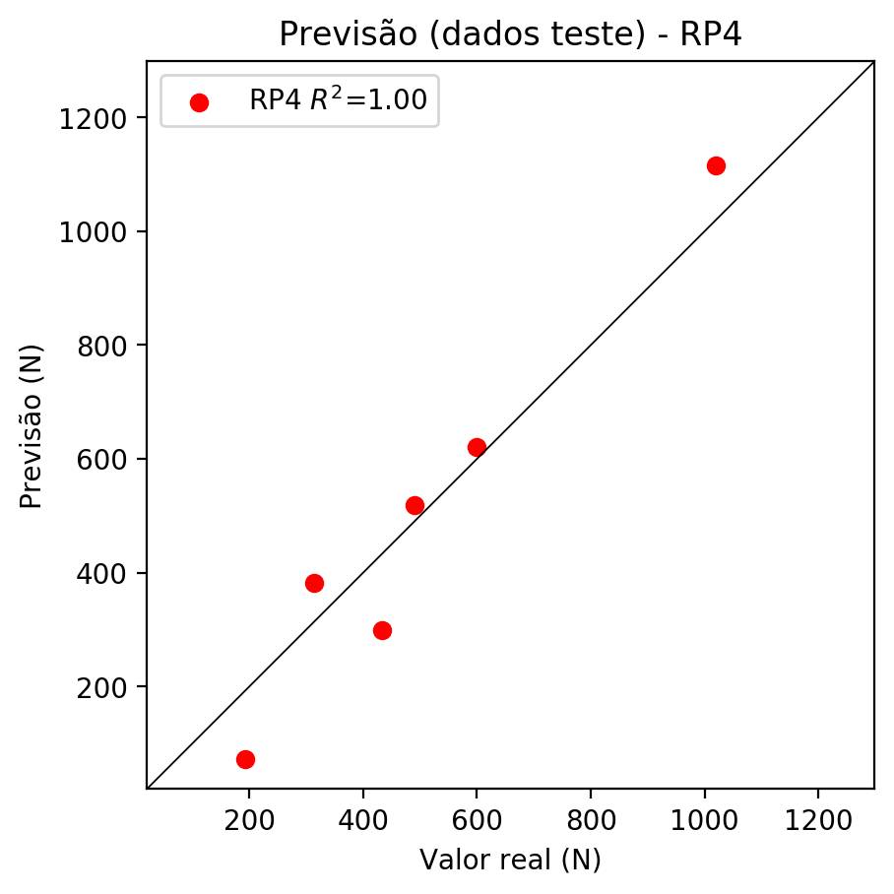

**Dados de treino**

* Erro relativo médio: 0.0
* Coeficiente de correlação: 1.0
* Coeficiente de determinação: 1.0
* MSE: 0.0
* RMSE: 0.0

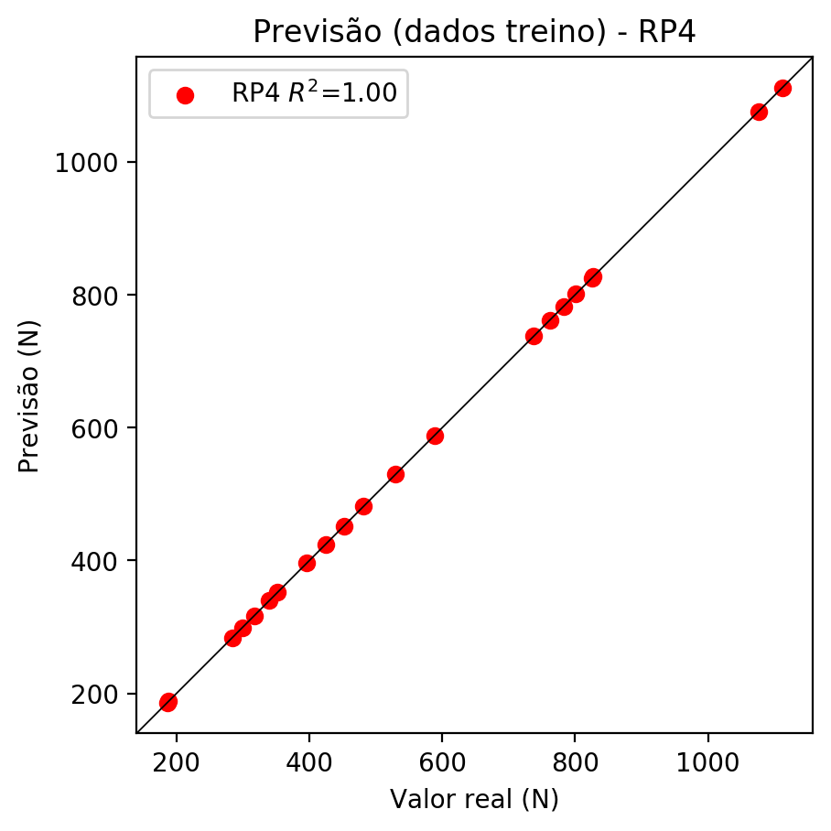

# Geral

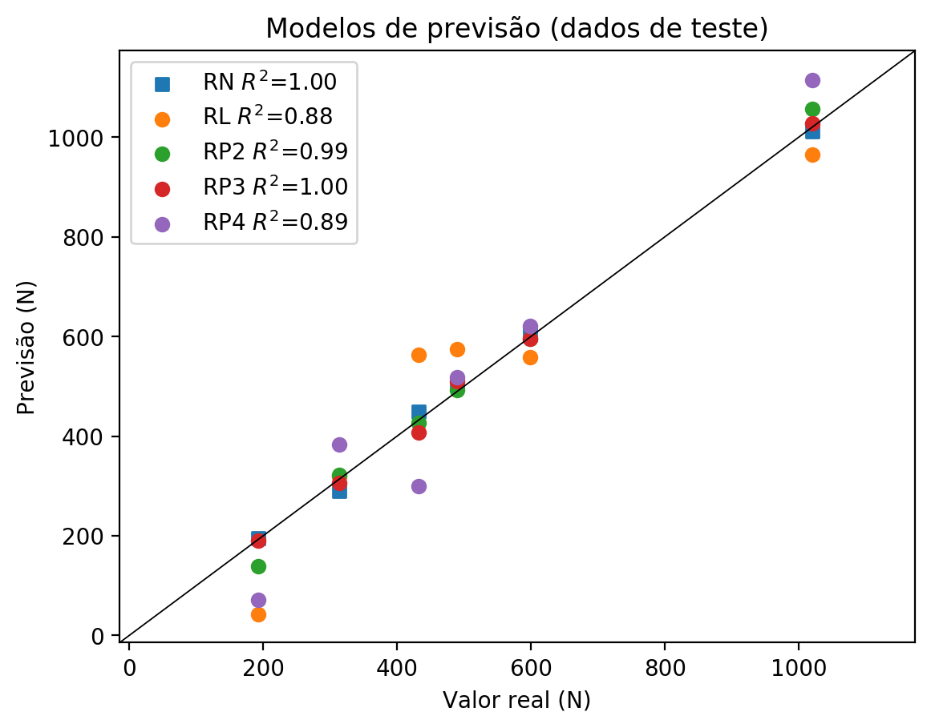

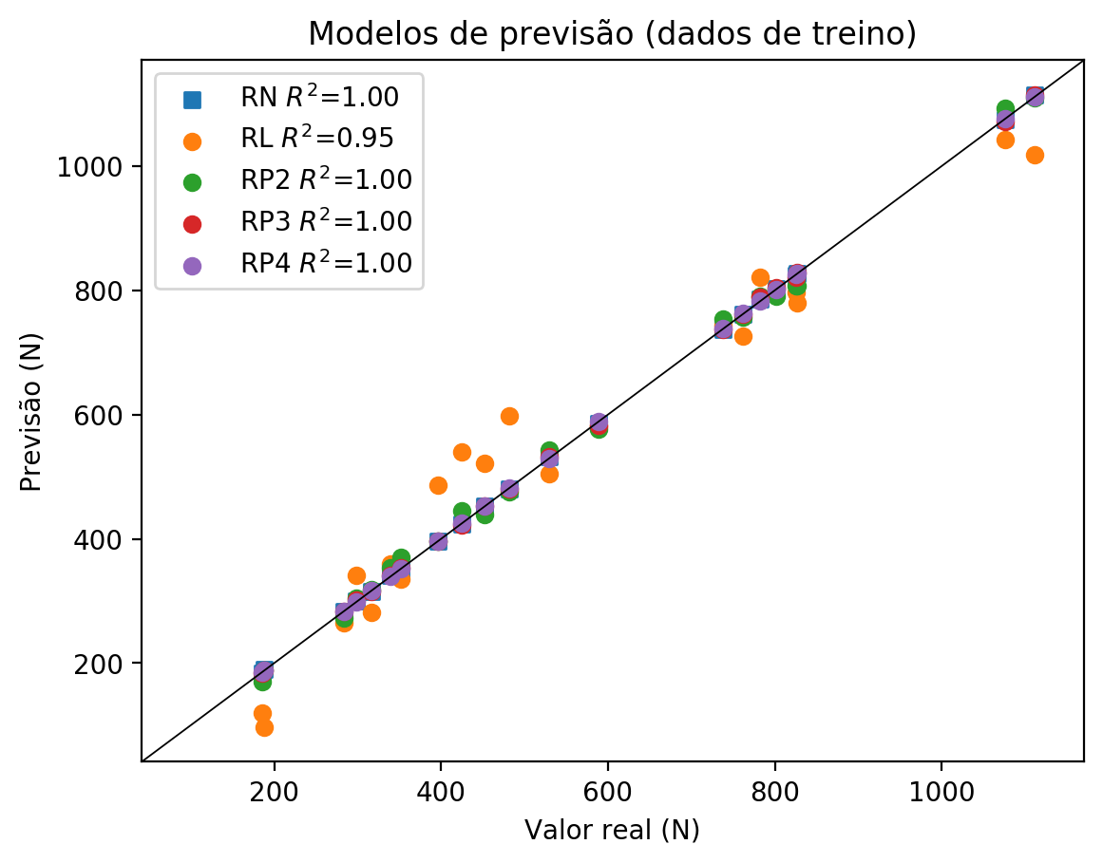

**Dados de teste**

|  |  |  |  |  |  |  |  |  |  |  |
| --- | --- | --- | --- | --- | --- | --- | --- | --- | --- | --- |
| Valor real | RN Previsto | RN Erro (%) | RL Previsto | RL Erro (%) | RP2 Previsto | RP2 Erro (%) | RP3 Previsto | RP3 Erro (%) | RP4 Previsto | RP4 Erro (%) |
| 192.4 | 195.23 | 1.47 | 42.99 | 77.66 | 138.87 | 27.82 | 190.51 | 0.98 | 72.04 | 62.56 |
| 1019.8 | 1011.17 | 0.85 | 965.01 | 5.37 | 1056.96 | 3.64 | 1027.28 | 0.73 | 1115.16 | 9.35 |
| 490.0 | 504.93 | 3.05 | 574.95 | 17.34 | 492.47 | 0.5 | 510.71 | 4.23 | 518.79 | 5.88 |
| 598.9 | 603.71 | 0.8 | 557.67 | 6.88 | 594.62 | 0.71 | 595.9 | 0.5 | 621.04 | 3.7 |
| 314.1 | 289.87 | 7.71 | 318.52 | 1.41 | 322.47 | 2.66 | 306.64 | 2.38 | 382.38 | 21.74 |
| 432.7 | 449.03 | 3.77 | 563.86 | 30.31 | 426.69 | 1.39 | 406.47 | 6.06 | 299.5 | 30.78 |

**Dados de treino**

|  |  |  |  |  |  |  |  |  |  |  |
| --- | --- | --- | --- | --- | --- | --- | --- | --- | --- | --- |
| Valor real | RN Previsto | RN Erro (%) | RL Previsto | RL Erro (%) | RP2 Previsto | RP2 Erro (%) | RP3 Previsto | RP3 Erro (%) | RP4 Previsto | RP4 Erro (%) |
| 827.1 | 826.87 | 0.03 | 779.53 | 5.75 | 807.77 | 2.34 | 828.24 | 0.14 | 827.1 | 0.0 |
| 481.7 | 480.95 | 0.16 | 598.43 | 24.23 | 475.89 | 1.21 | 479.81 | 0.39 | 481.7 | 0.0 |
| 762.2 | 761.58 | 0.08 | 725.86 | 4.77 | 756.52 | 0.75 | 760.79 | 0.18 | 762.2 | 0.0 |
| 782.5 | 785.47 | 0.38 | 820.3 | 4.83 | 789.98 | 0.96 | 789.41 | 0.88 | 782.5 | 0.0 |
| 588.4 | 586.21 | 0.37 | 581.14 | 1.23 | 577.02 | 1.93 | 582.06 | 1.08 | 588.4 | 0.0 |
| 188.2 | 189.96 | 0.94 | 96.65 | 48.65 | 188.86 | 0.35 | 188.54 | 0.18 | 188.2 | 0.0 |
| 424.7 | 423.97 | 0.17 | 540.38 | 27.24 | 445.3 | 4.85 | 422.86 | 0.43 | 424.7 | 0.0 |
| 1111.7 | 1113.72 | 0.18 | 1018.68 | 8.37 | 1110.17 | 0.14 | 1114.59 | 0.26 | 1111.7 | 0.0 |
| 1076.1 | 1073.88 | 0.21 | 1042.16 | 3.15 | 1093.28 | 1.6 | 1072.12 | 0.37 | 1076.1 | 0.0 |
| 352.2 | 351.17 | 0.29 | 335.8 | 4.66 | 370.69 | 5.25 | 354.05 | 0.53 | 352.2 | 0.0 |
| 316.8 | 315.59 | 0.38 | 282.14 | 10.94 | 318.73 | 0.61 | 315.34 | 0.46 | 316.8 | 0.0 |
| 298.8 | 299.63 | 0.28 | 341.99 | 14.45 | 304.01 | 1.74 | 301.28 | 0.83 | 298.8 | 0.0 |
| 737.9 | 736.88 | 0.14 | 743.15 | 0.71 | 753.13 | 2.06 | 737.56 | 0.05 | 737.9 | 0.0 |
| 396.2 | 396.68 | 0.12 | 486.71 | 22.84 | 396.04 | 0.04 | 396.94 | 0.19 | 396.2 | 0.0 |
| 339.5 | 341.47 | 0.58 | 359.28 | 5.83 | 353.25 | 4.05 | 341.3 | 0.53 | 339.5 | 0.0 |
| 825.6 | 823.49 | 0.26 | 796.82 | 3.49 | 806.71 | 2.29 | 821.22 | 0.53 | 825.6 | 0.0 |
| 283.8 | 283.04 | 0.27 | 264.85 | 6.68 | 272.84 | 3.86 | 283.51 | 0.1 | 283.8 | 0.0 |
| 185.9 | 184.18 | 0.93 | 120.13 | 35.38 | 170.55 | 8.26 | 184.46 | 0.77 | 185.9 | 0.0 |
| 801.1 | 802.48 | 0.17 | 803.01 | 0.24 | 790.01 | 1.38 | 803.56 | 0.31 | 801.1 | 0.0 |
| 529.7 | 531.82 | 0.4 | 504.0 | 4.85 | 543.01 | 2.51 | 531.67 | 0.37 | 529.7 | 0.0 |
| 452.2 | 453.3 | 0.24 | 521.29 | 15.28 | 438.53 | 3.02 | 453.0 | 0.18 | 452.2 | 0.0 |